**AWS Application Load Balancer with Auto Scaling group**

Go to AWS console

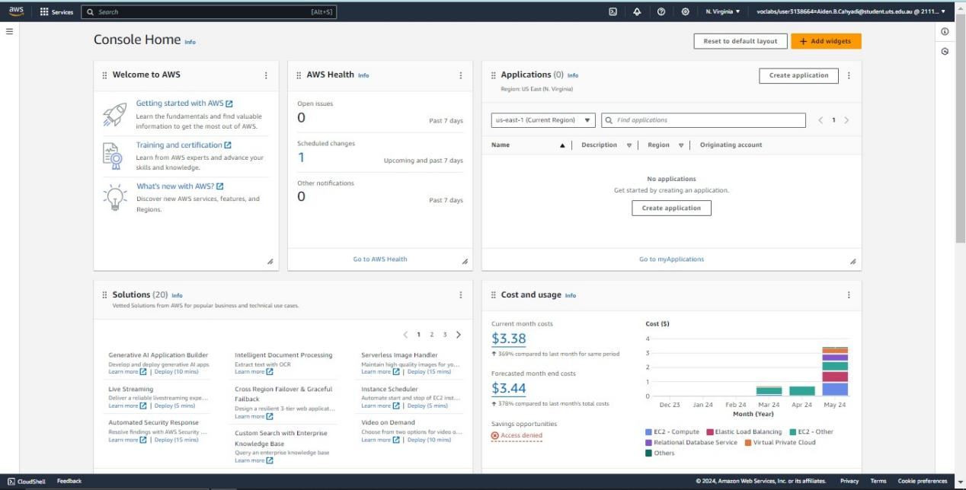

Go to VPC

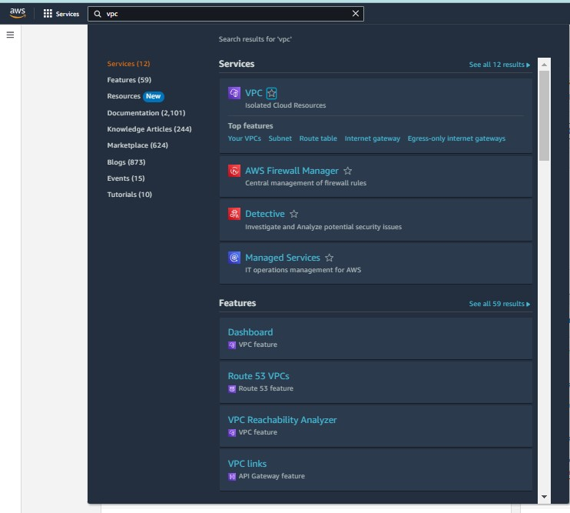

Click Create a new vpc

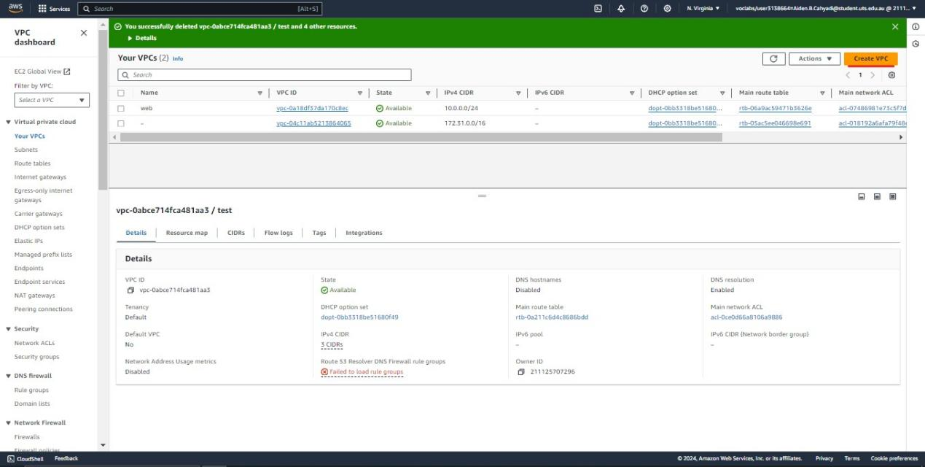

Now give the vpc details

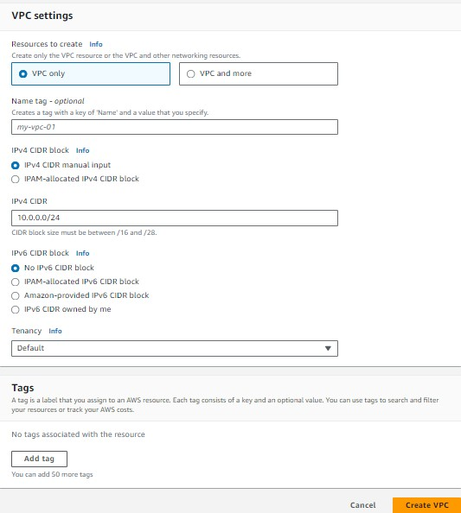

Now here we can see the created vpc

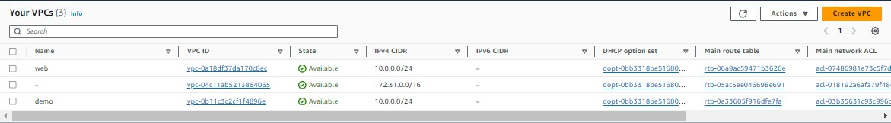

Now go to subnet

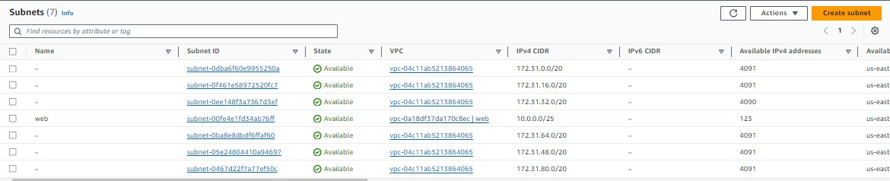

Connect our VPC 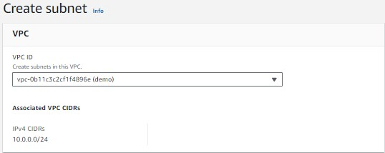

Now give the subnet details

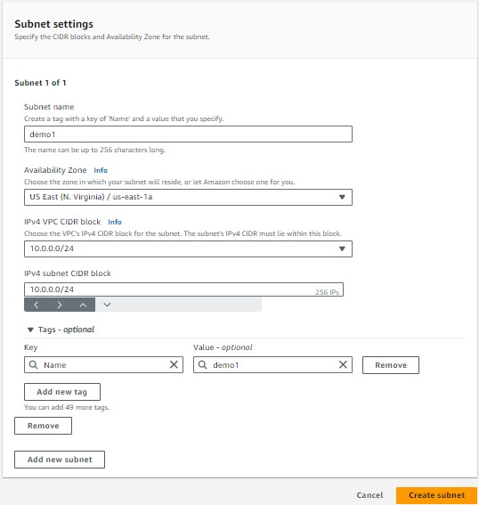

Here we can see our subnet

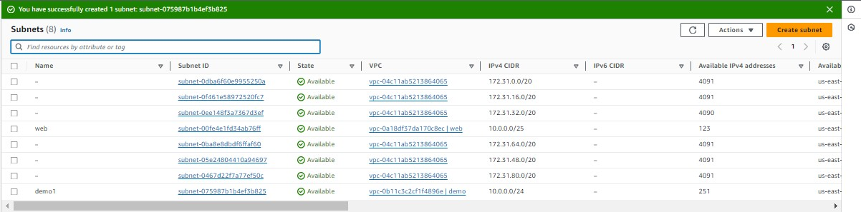

Now go to EC2

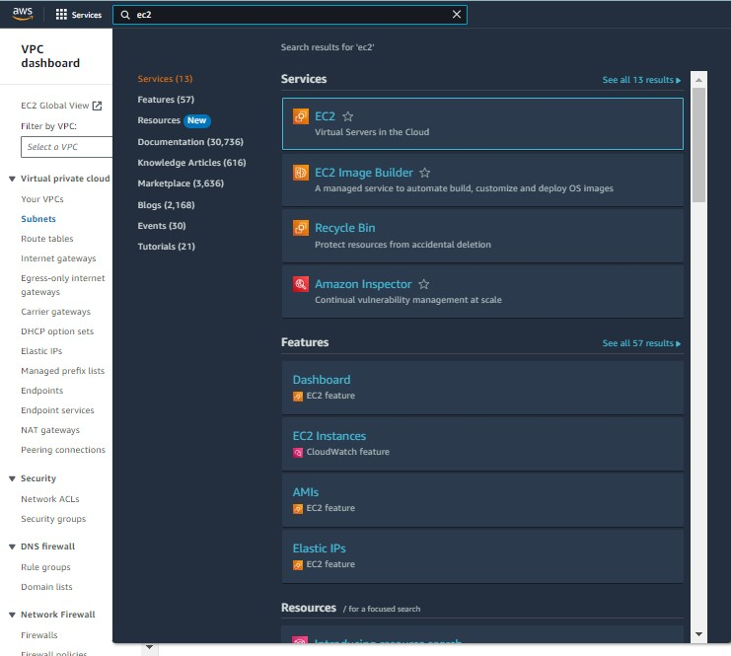

Now click the security group 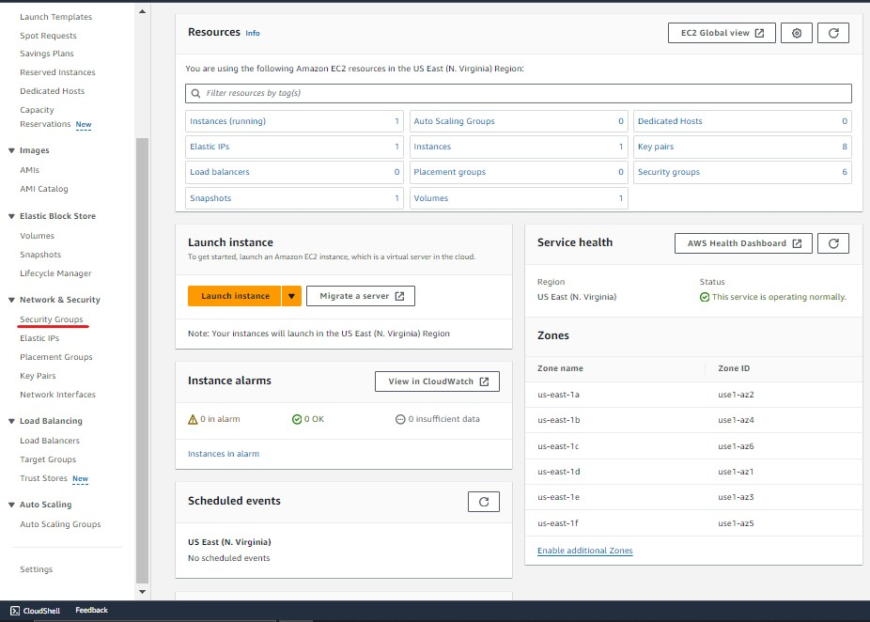

Now click on create security group

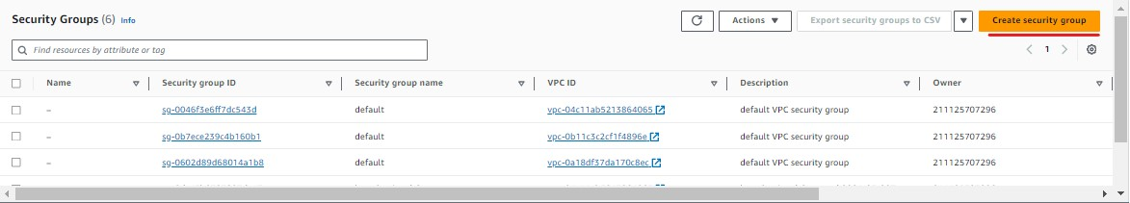

Give the security group details

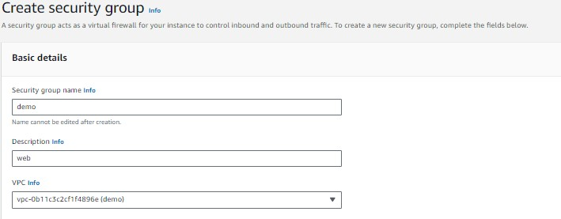

Add the inbound rules of our group   
>http - 80

>https - 80

>ssh - 22  
>MYSQL - 3066

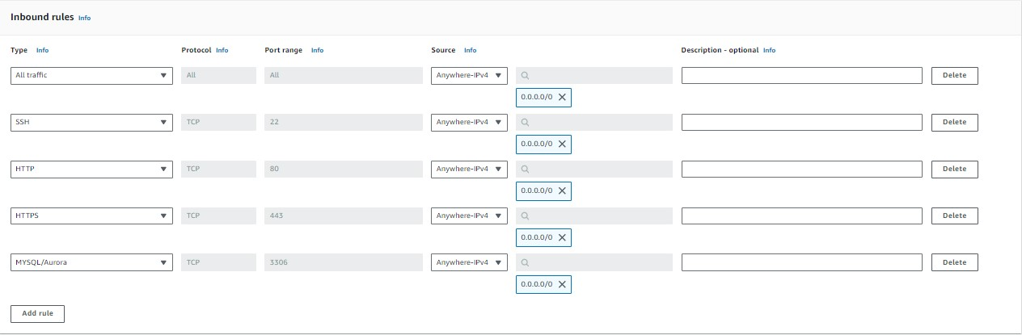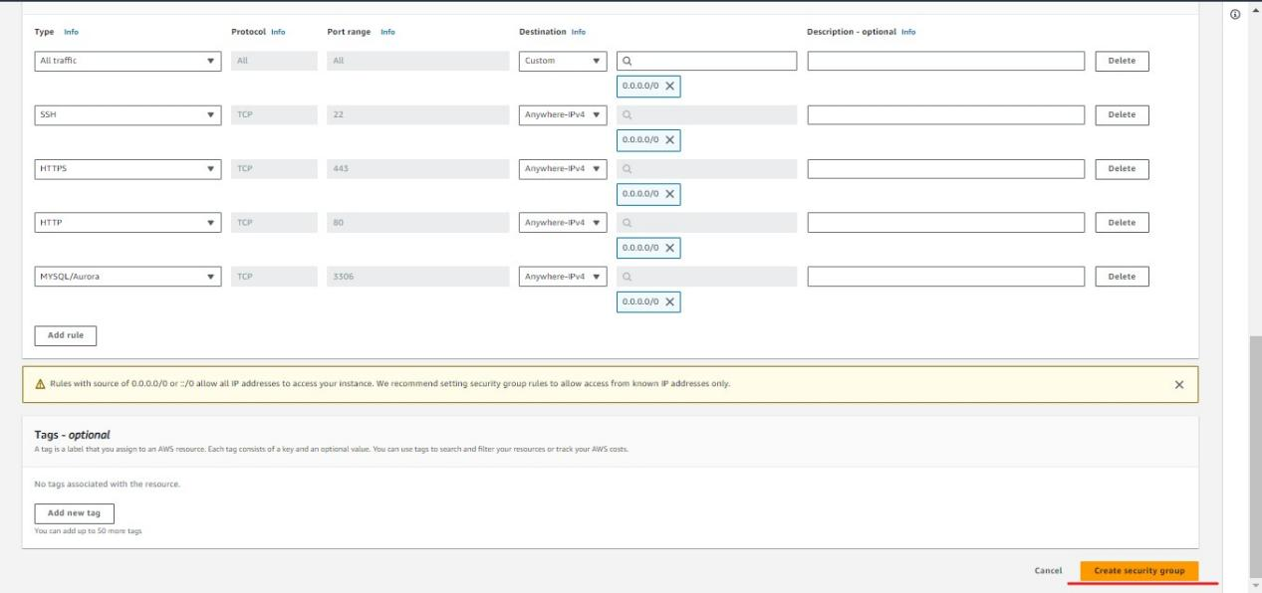

Here we can see our security group

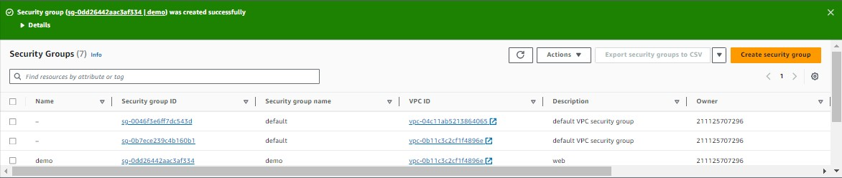

Now go to RDS 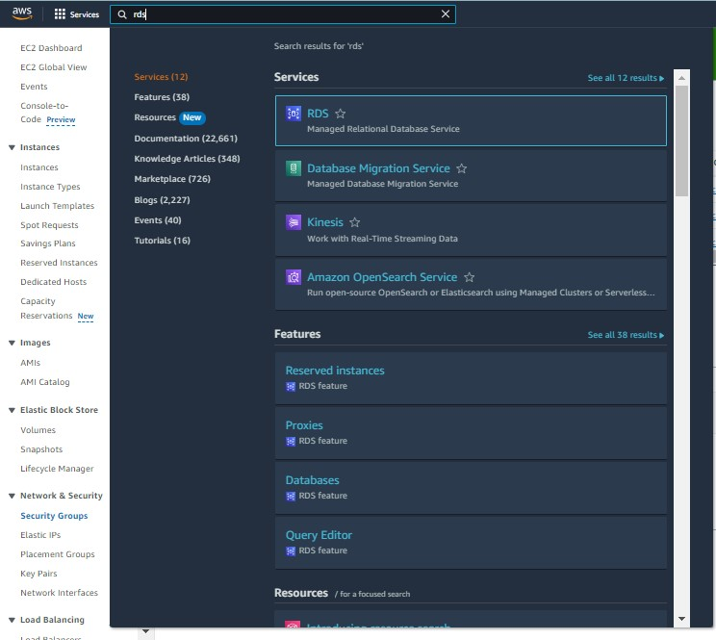

Click on Create database

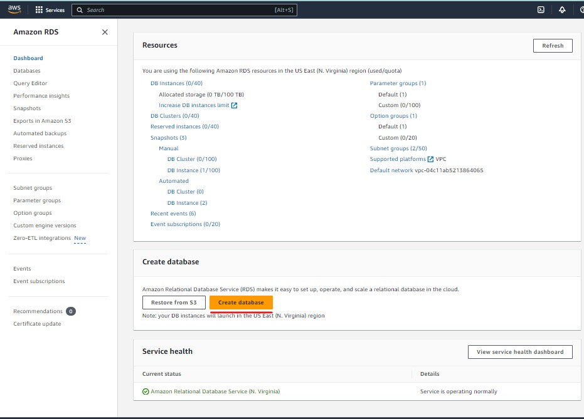

Now select the creation method 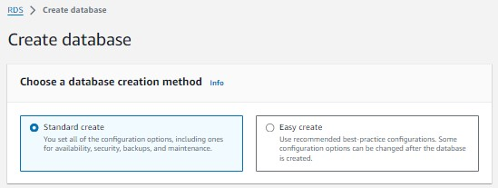

Now select the DB type

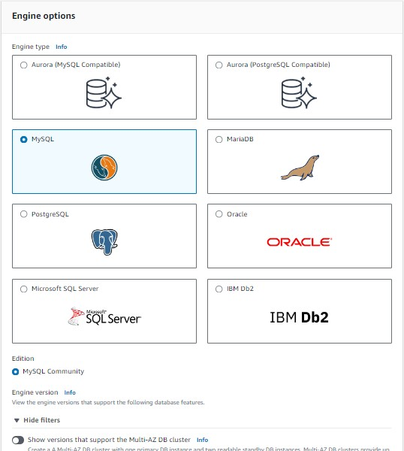

Select the free tier

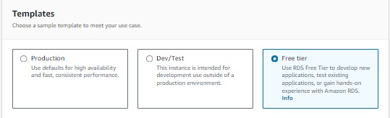

Give the user name and password

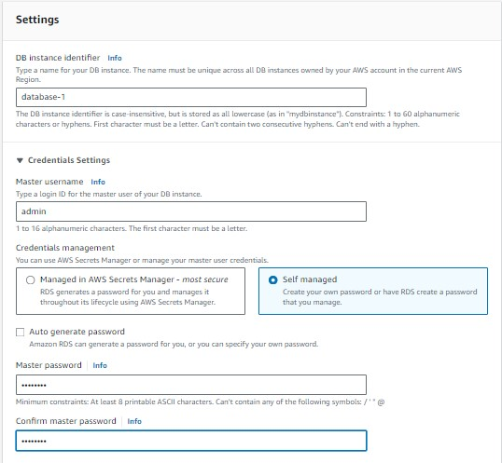

Now give network details 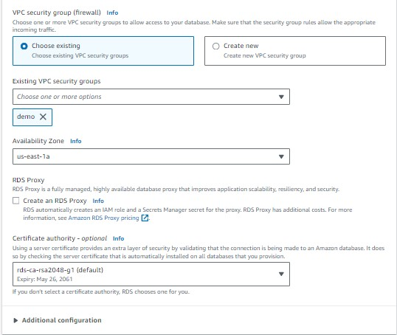

Now give the db name

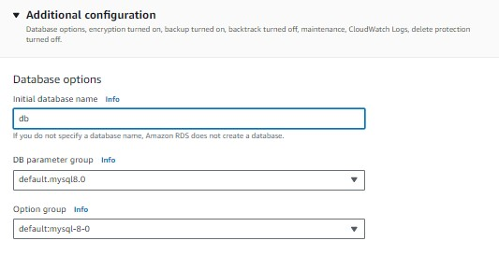

Now create the DB name 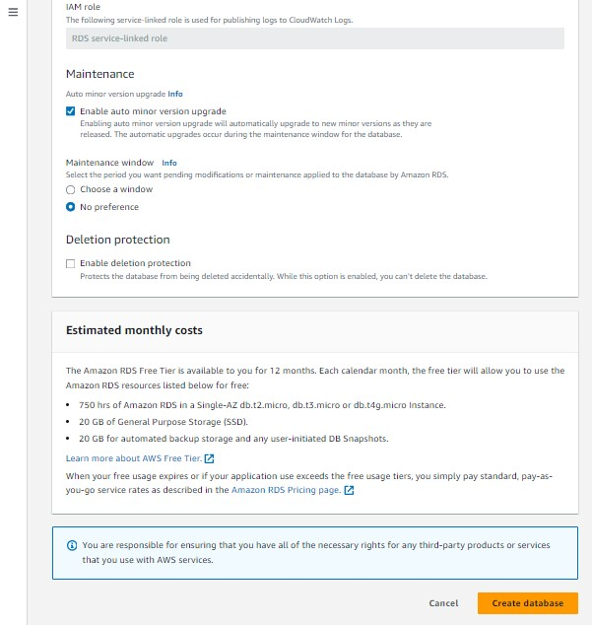

Here we can see the DB now copy the DB end port link

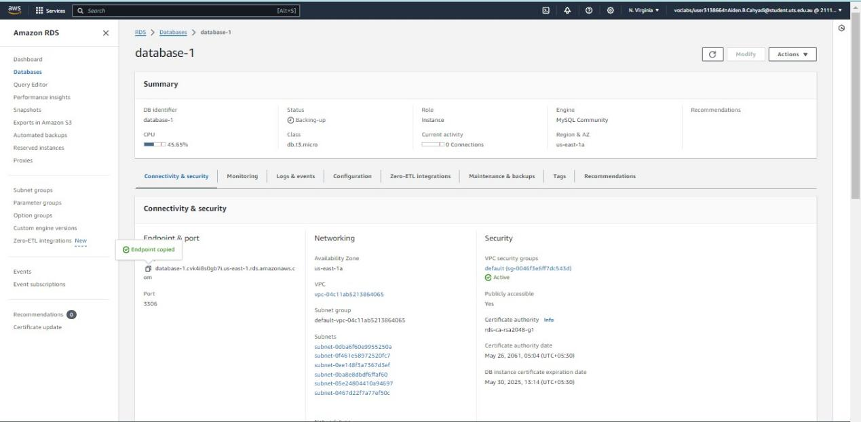

Now add it in the link in the php code

<?php

define('DB_SERVER', 'database-1.cvk4i8s0gb7i.us-east-1.rds.amazonaws.com');

define('DB_USERNAME', 'admin');

define('DB_PASSWORD', 'admin123');

define('DB_DATABASE', 'db');

?>

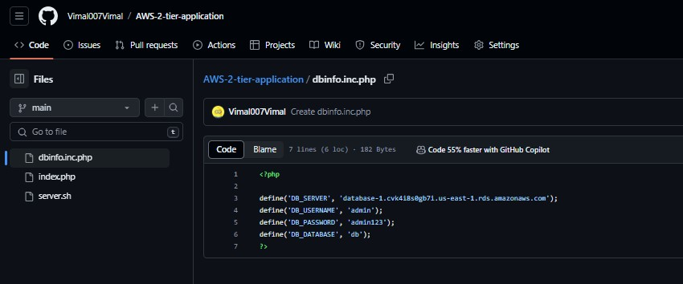

Now go to EC2

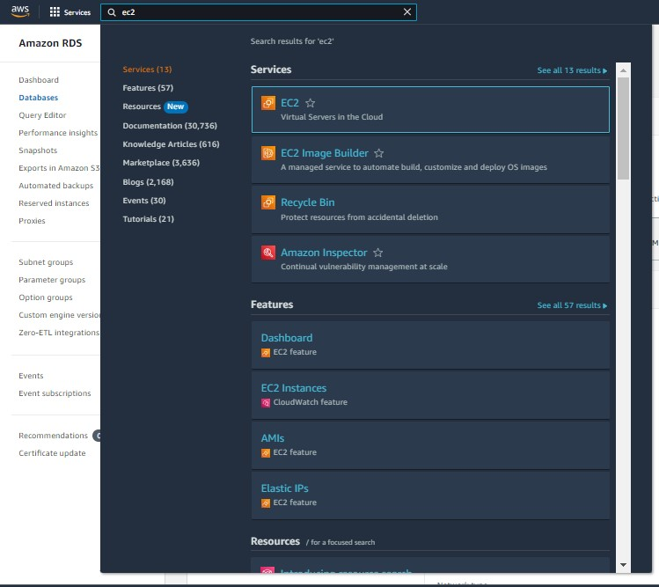

Go to Auto Scaling group 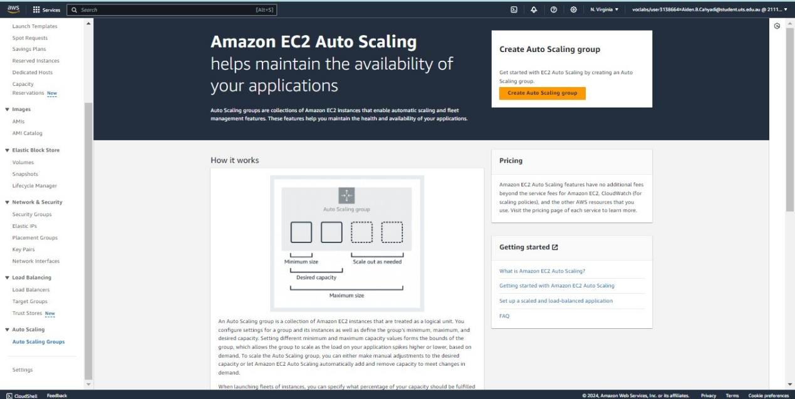

Give the ACG name and click on launch templete

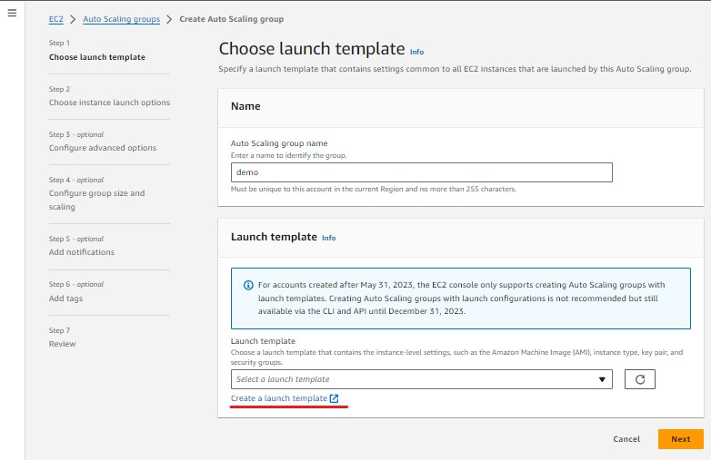

Now give it name

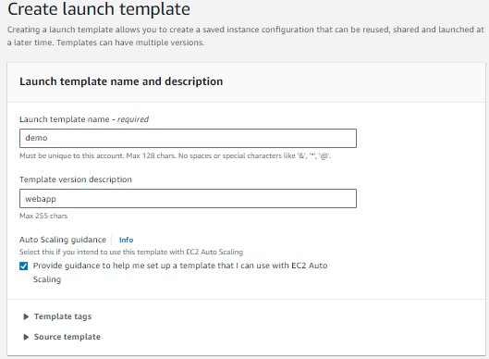

Select the os type - we are selecting ubantu

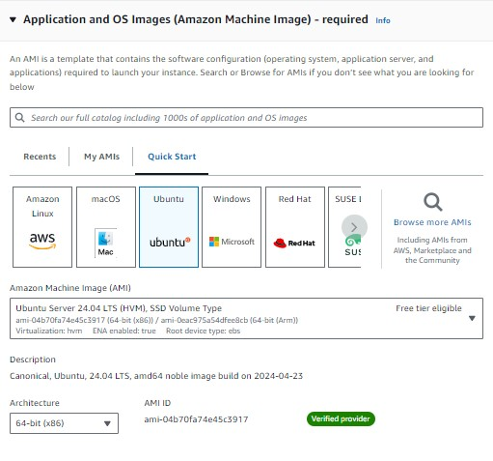

Now select instance type 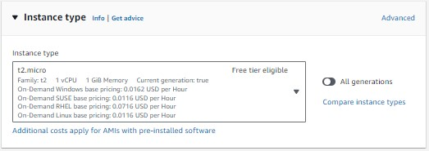

Now create nw key pair

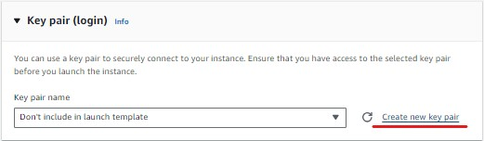

Give it a name and download it

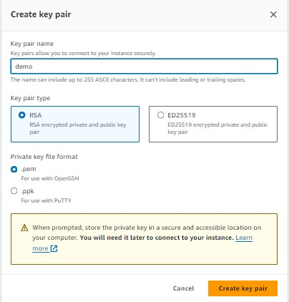

Now give I the network details of our vpc and subnet 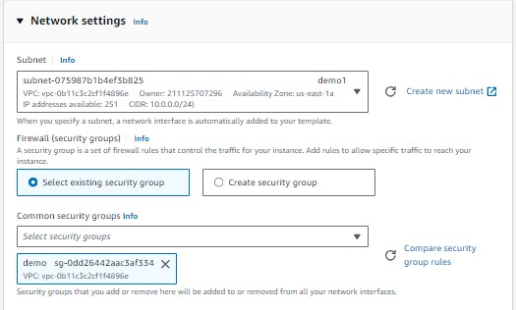

Give the additional details

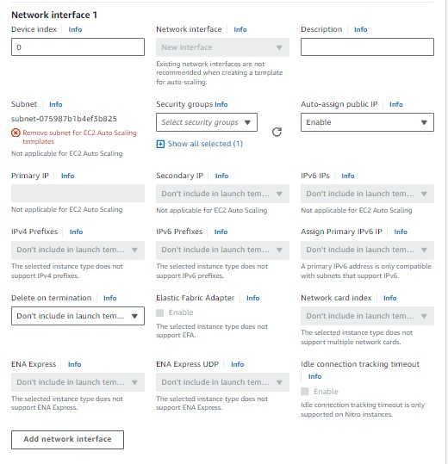

Go to advanced details

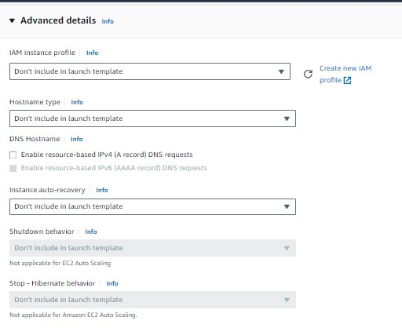

Here we need to give script so all the instance which is created by the ASG - The server will be configure automatically

#!/bin/bash

sudo su

# Update package list

apt update -y

# Install Apache web server

apt install apache2 -y

# Install PHP and necessary PHP modules

apt install php libapache2-mod-php php-mysql -y

# Install MySQL client

apt install mysql-client -y

# Install archive management tools

apt install rar unrar zip unzip -y

# Install Git

apt install git -y

# Navigate to the web server's root directory

cd /var/www/html/

# Clone the GitHub repository

git clone https://github.com/Vimal007Vimal/AWS-2-tier-application.git

# Remove the default Apache index file

rm -f index.html

# Move the contents of the cloned repository to the web server's root directory

cd AWS-2-tier-application

mv * /var/www/html/

# Navigate back and remove the empty directory

cd ..

rmdir AWS-2-tier-application

# Restart and enable Apache web server

systemctl restart apache2

systemctl enable apache2

Here I have the code git link of our application

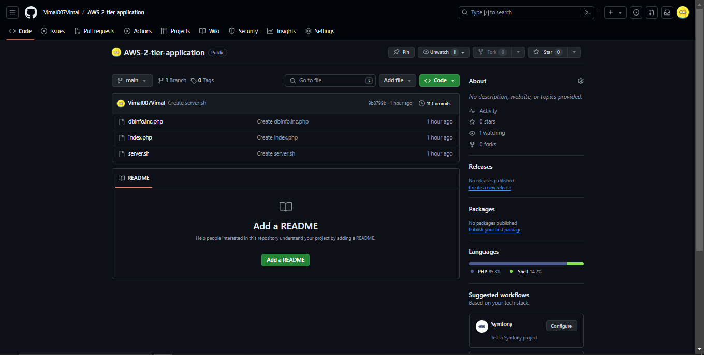

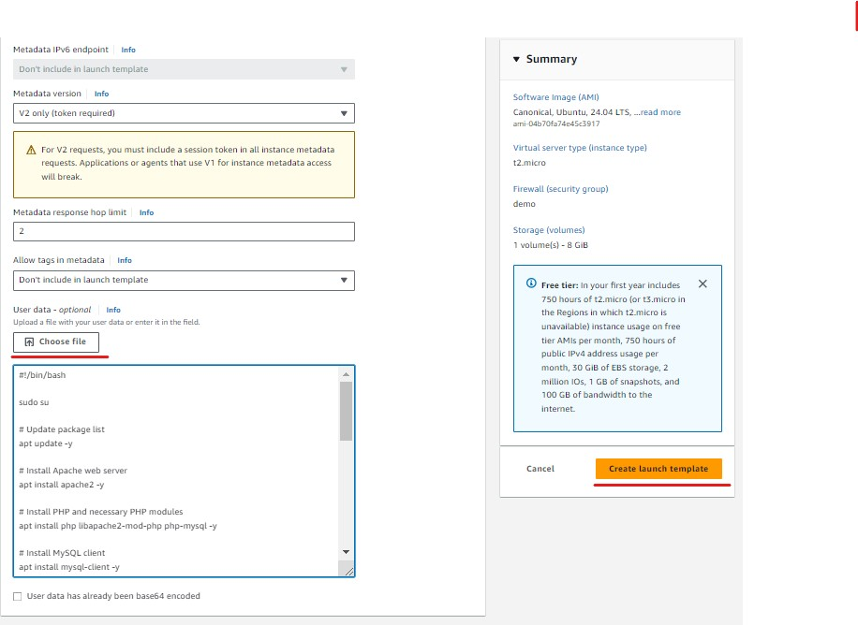

Now create it

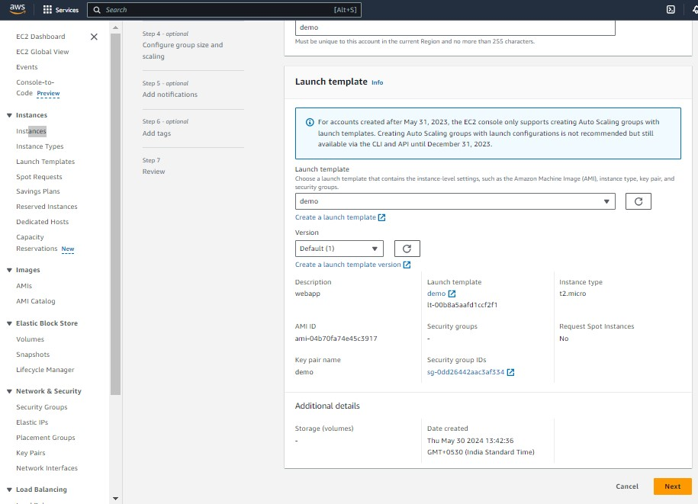

Here we can see the templete details - give next

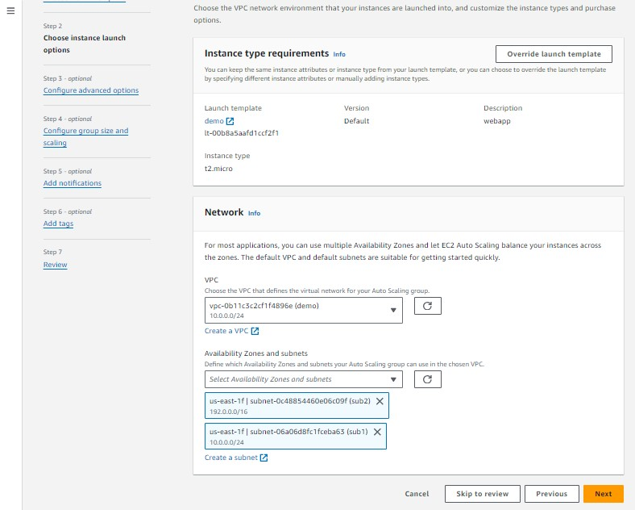

Here we need to give the network details - our vpc and subnet

And give next

Here we need to LB(load balancer) details

Give new load attach a new load balancer

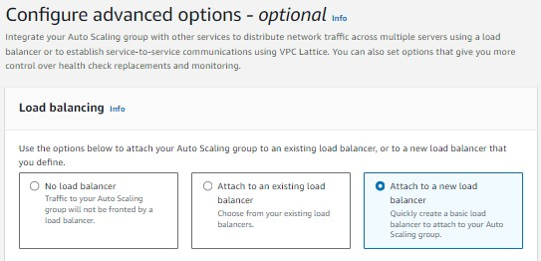

Select the type its network details

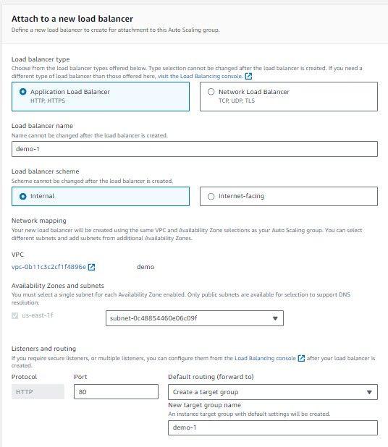

Click on health checks and give next

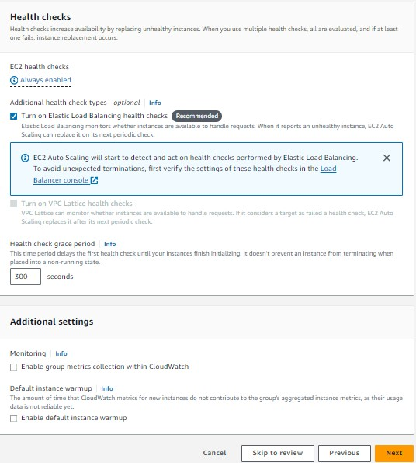

Now give the group size

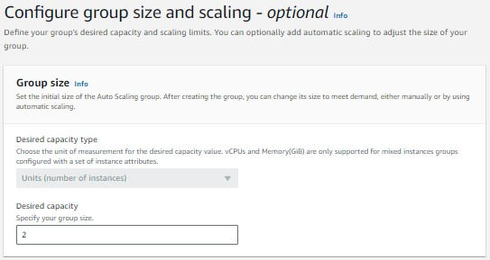

Now give the scaling details and give automatic scaling policy

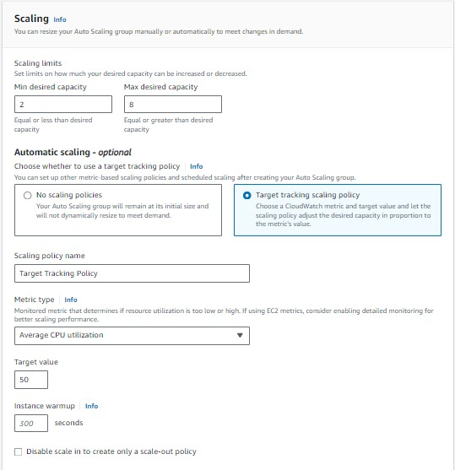

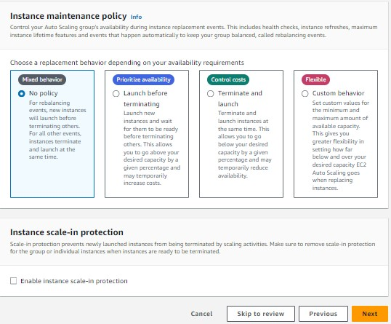

give next here

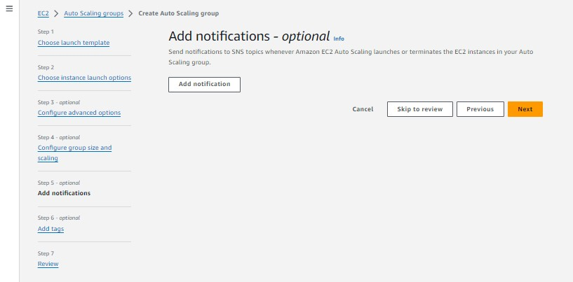

Give next here

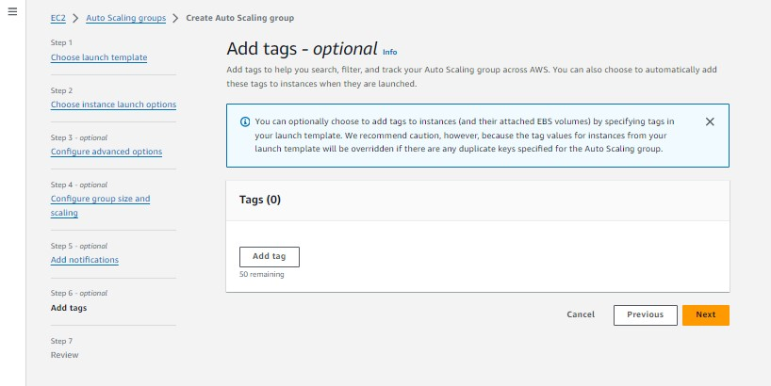

Now review the details

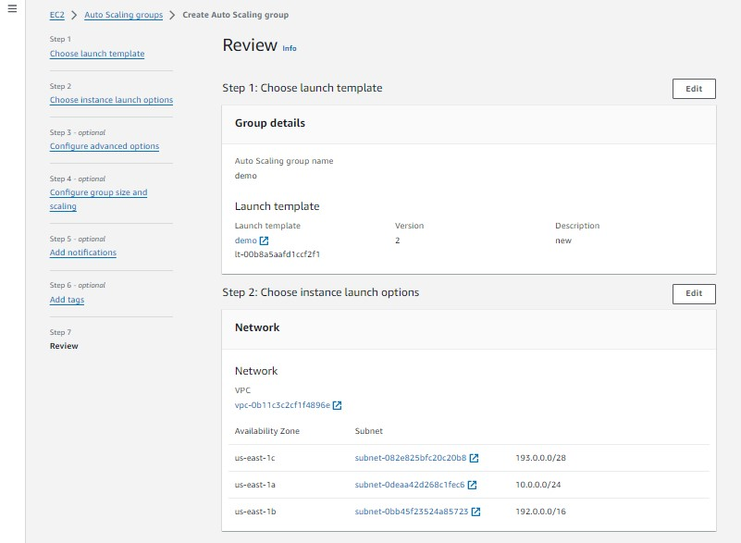

Now create it

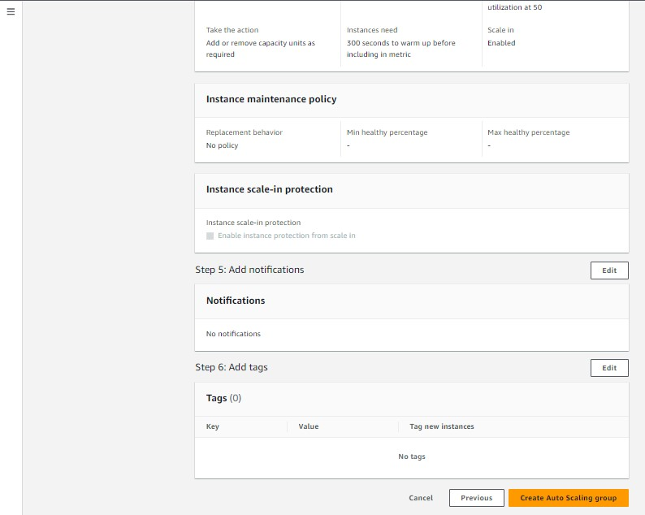

Here we can see the ASG(auto scaling group)

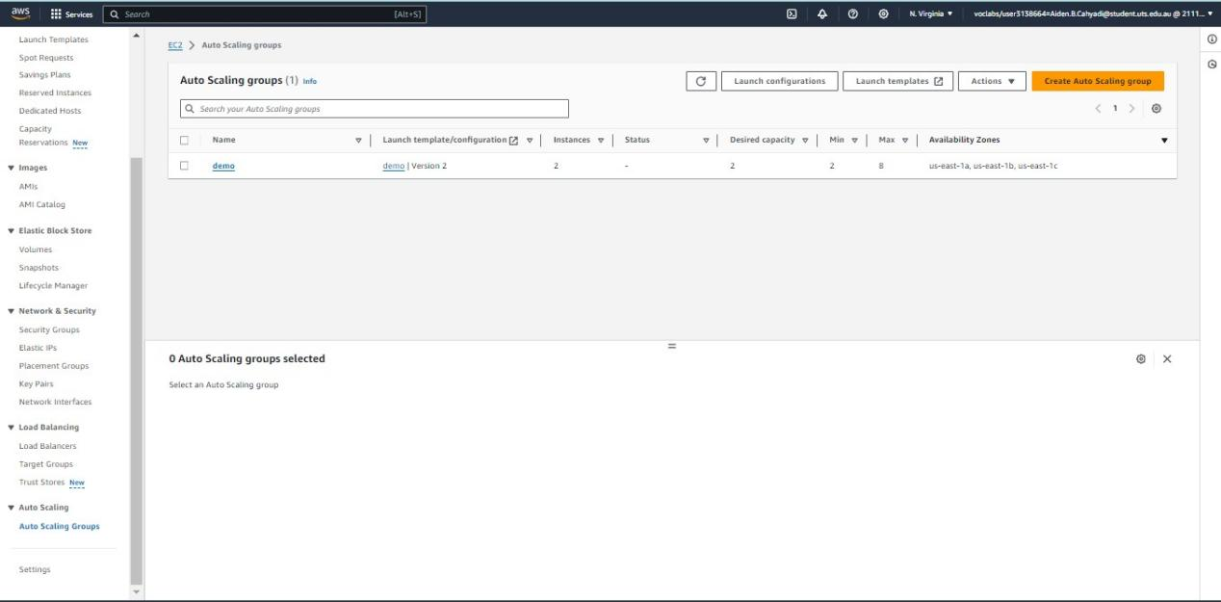

Here we can see our Target groups

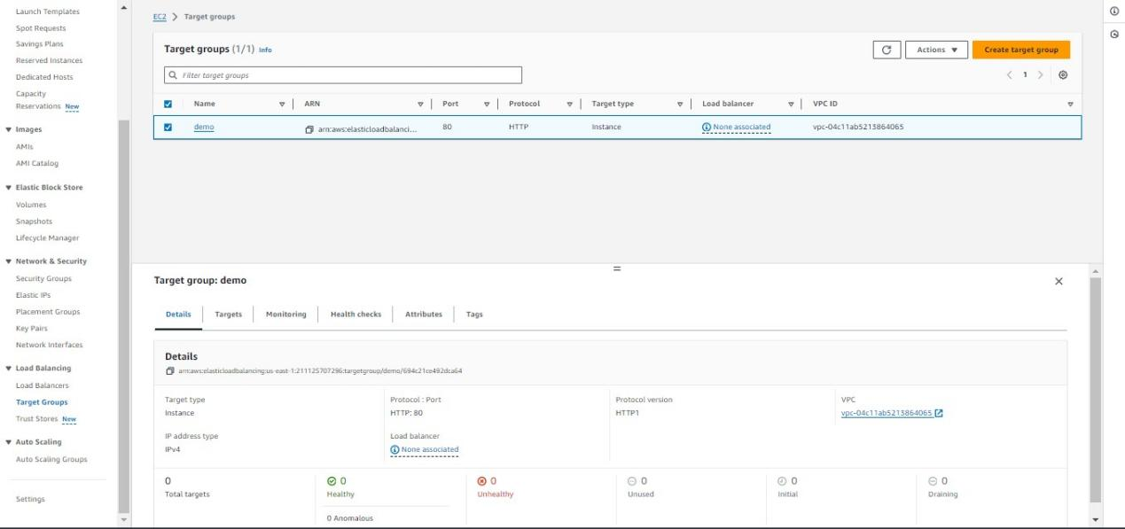

Here we can see our load balances

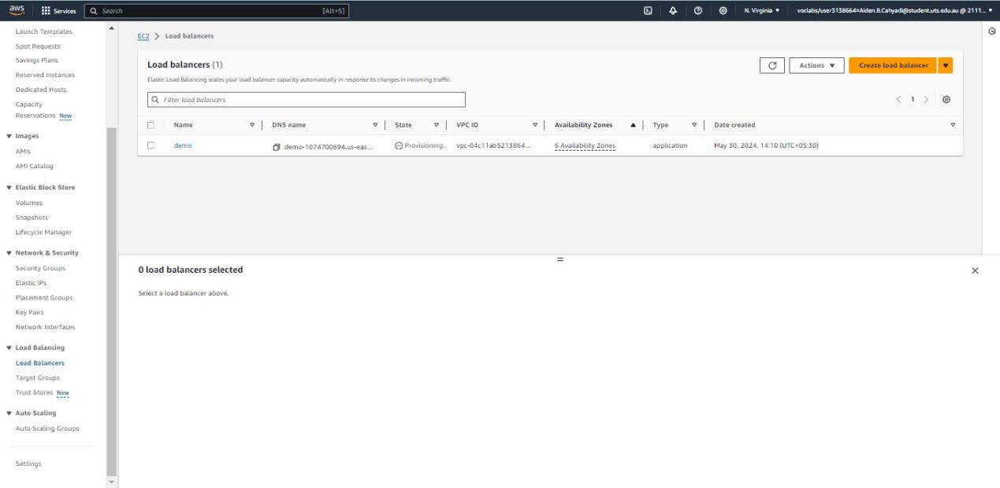

Here we can see our instances

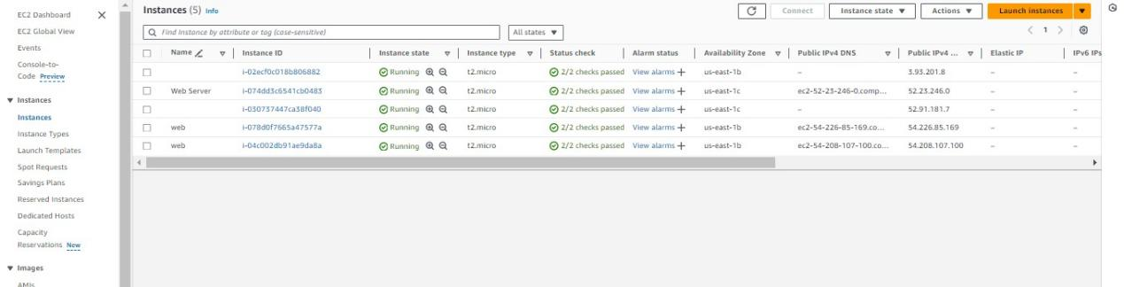

Now copy the DNS of load balances

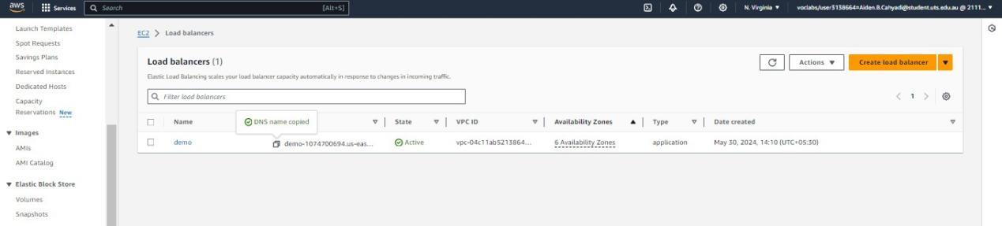

Here check it in the webpage

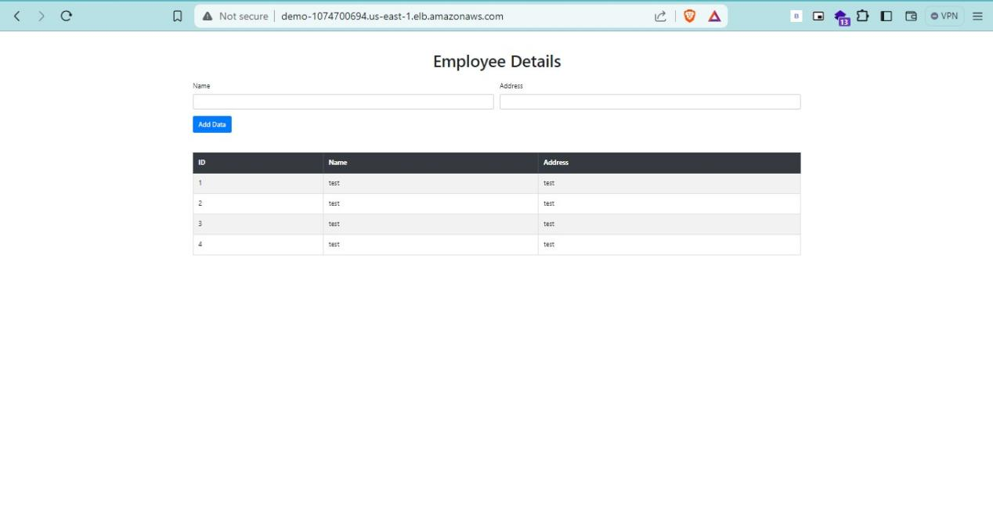

Here we can see the application from LB

Now go to one of the instances and click connect

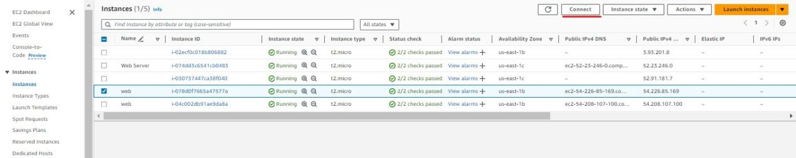

Select the ec2 instance connect option

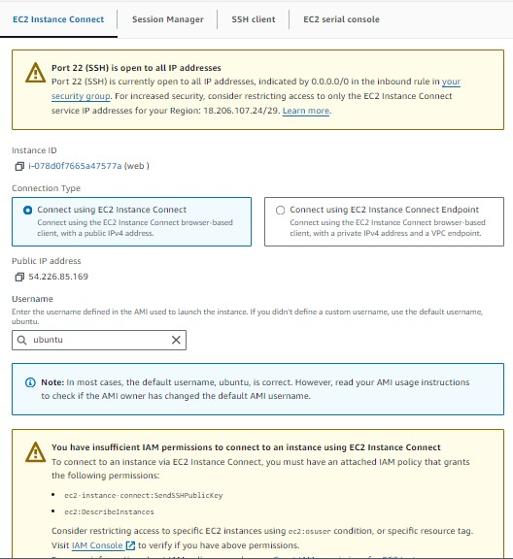

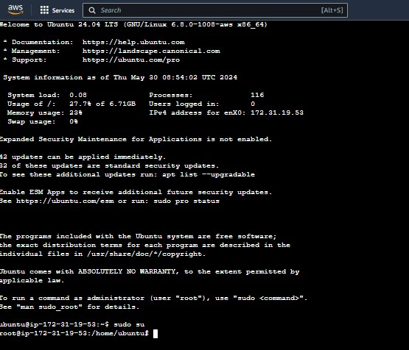

Here we have connected to the ubantu instance go to root user

Sudo su

Now go rds and copy the endpoint link

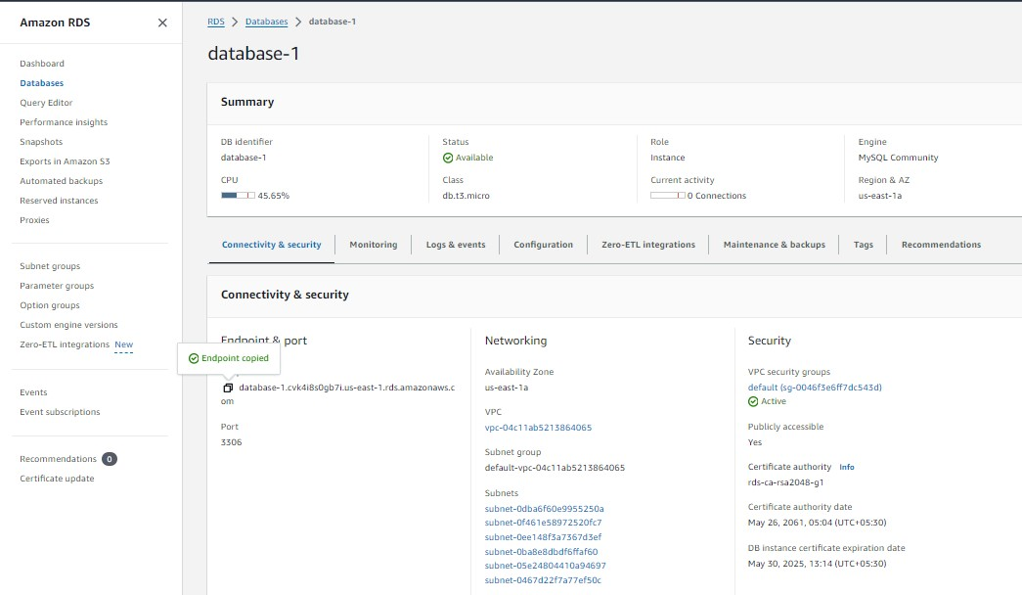

Mysql -u username -h <endpointlink> -p

Using this command connect to the DB from the ubantu instance

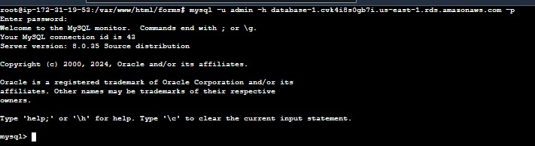

Now we have access to the db

SHOW DATABASES;

Here w can see our DB

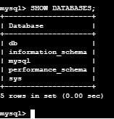

USE databaename;

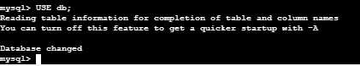

Now go to the LB load balances link and enter some data

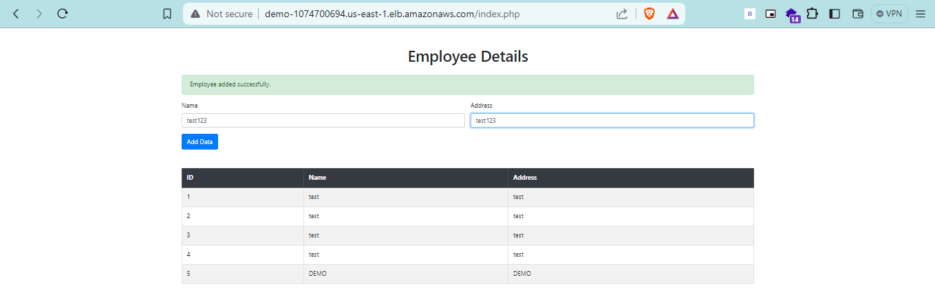

Now lets check the data have entered or not

SHOW TABLES;

SELECT * FROM tablename;

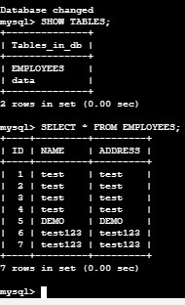

Now our data have entered in our DB

Now go to SNS service

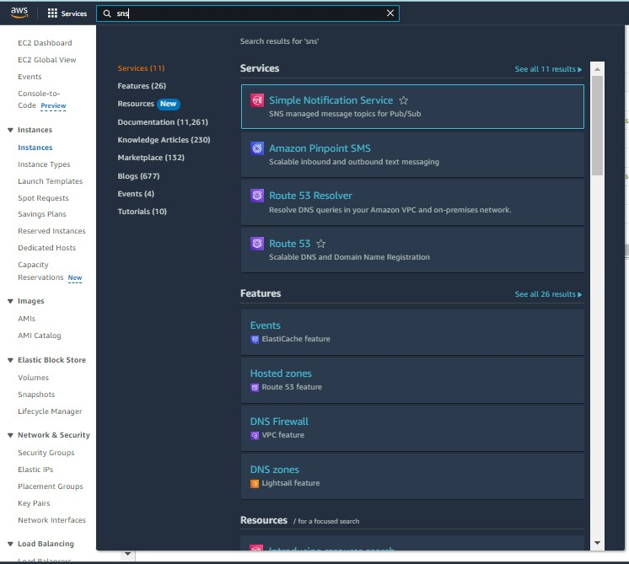

Give the name of topic   
  
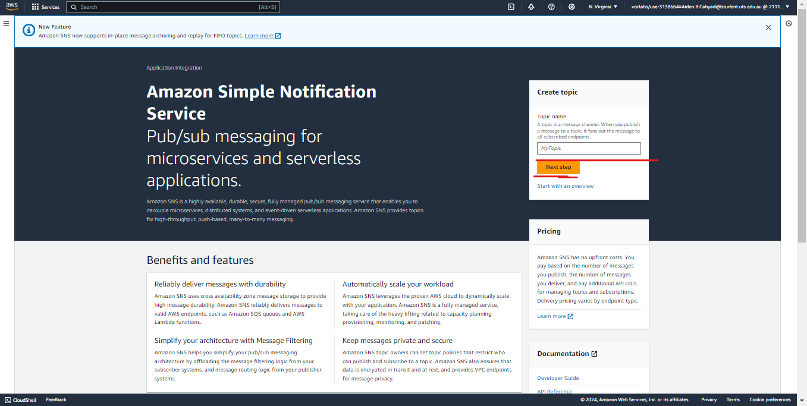

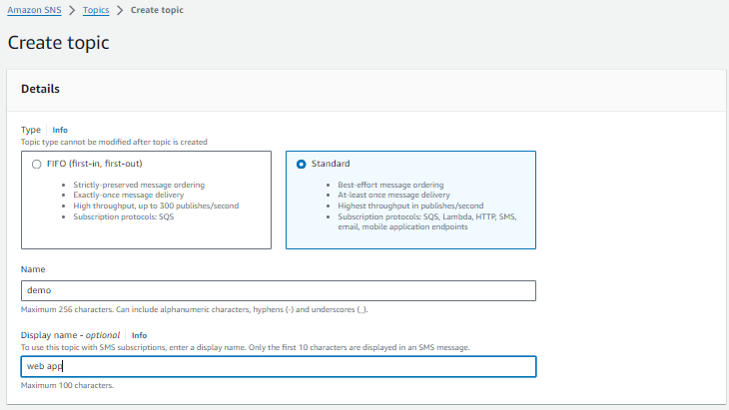

Select topic type and give name and give create topic

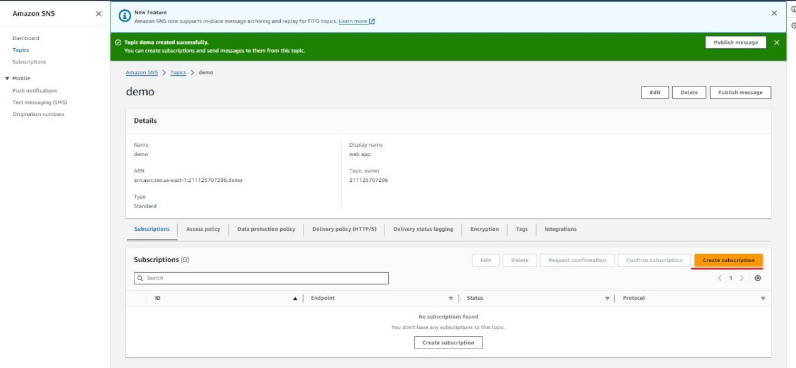

Here select the type of the service

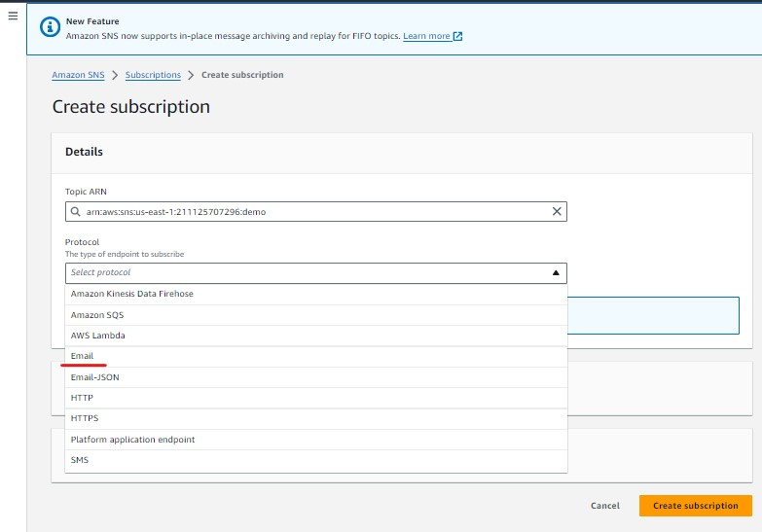

Give the email to it and click create subscription

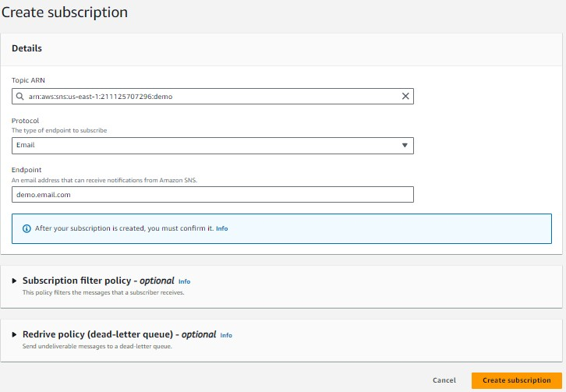

Now you will receive a mail to conform

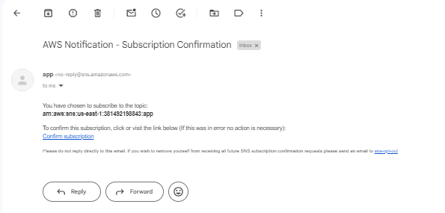

Here we can see our subscription 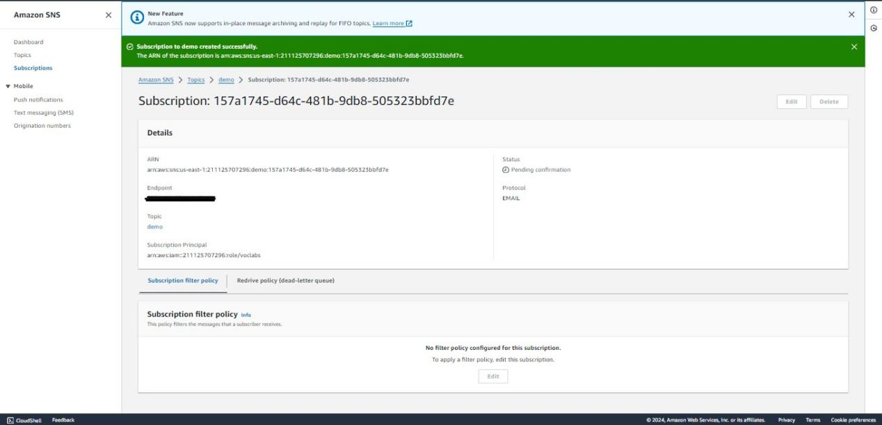

Now we need to set the alarm for that go to cloudwatch

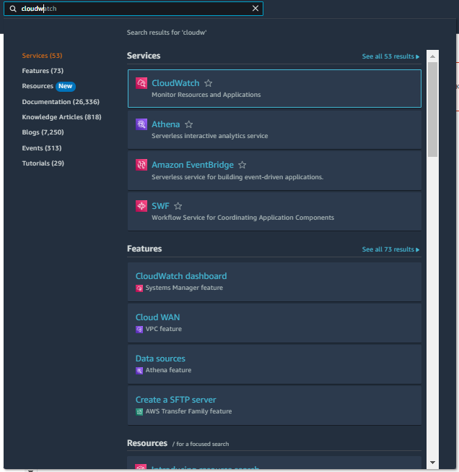

Select create alarm

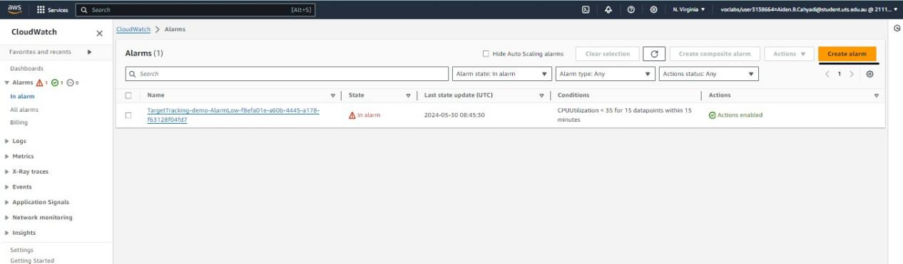

Click on select metric

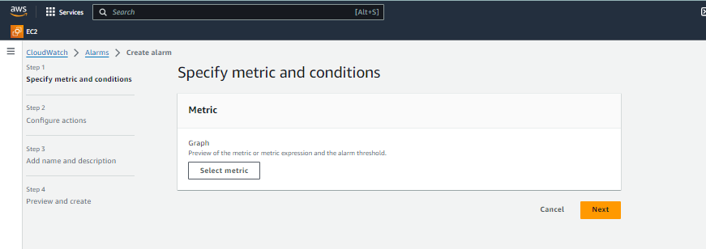

Selcet EC2

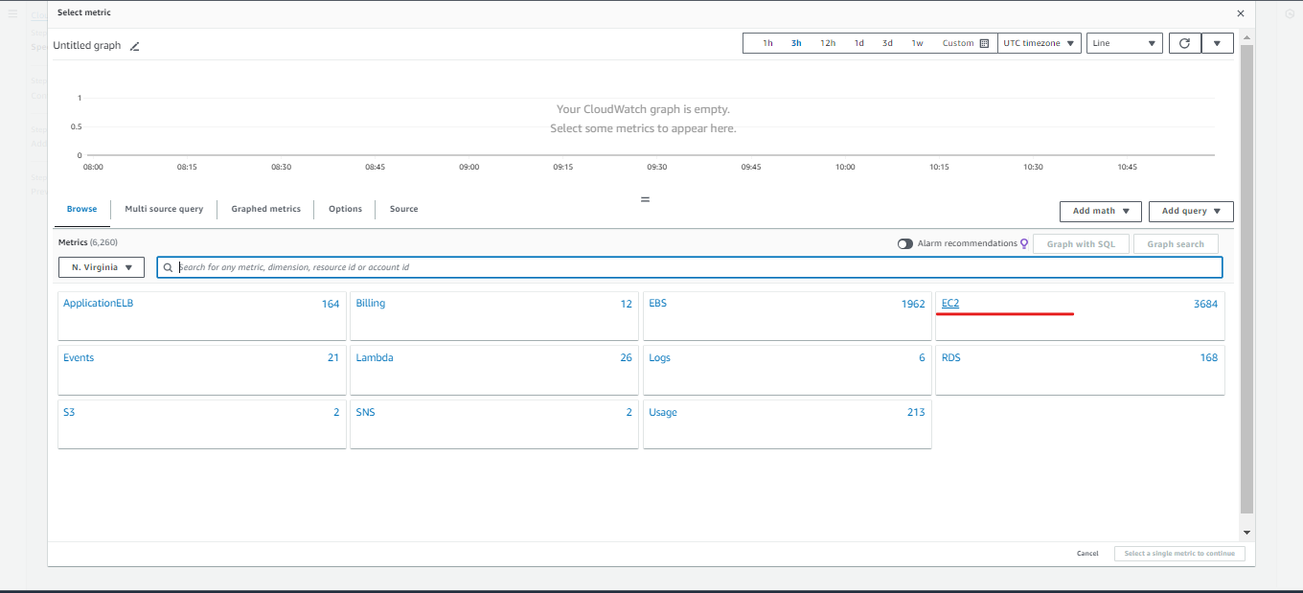

Select auto scaling ( because our instance is running from the template of auto scaling group )

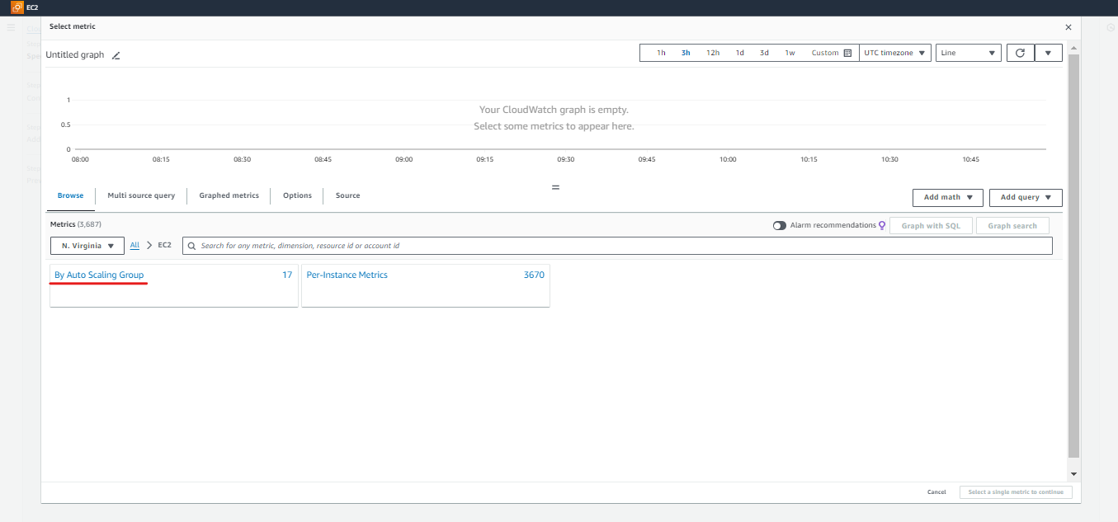

Select the metric you need ( here I have selected status check failed instances)

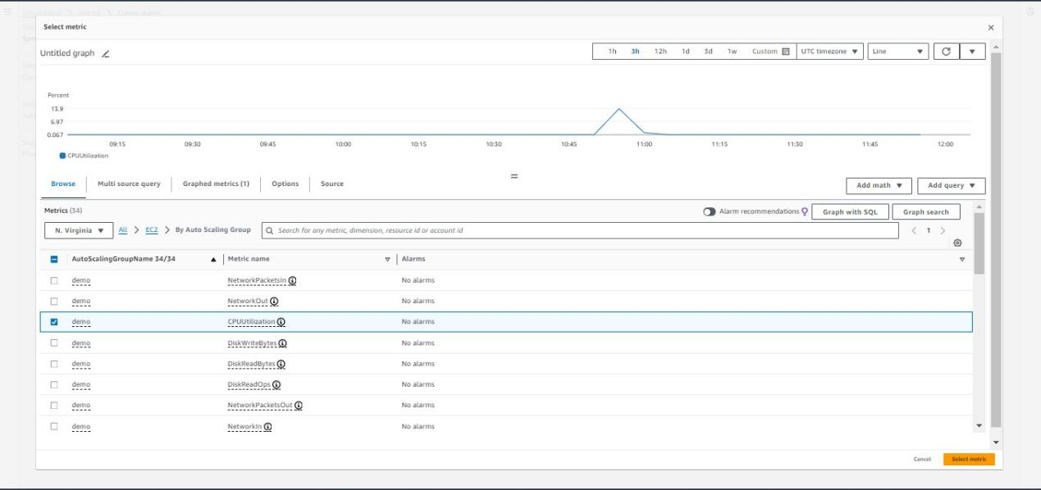

Now give next

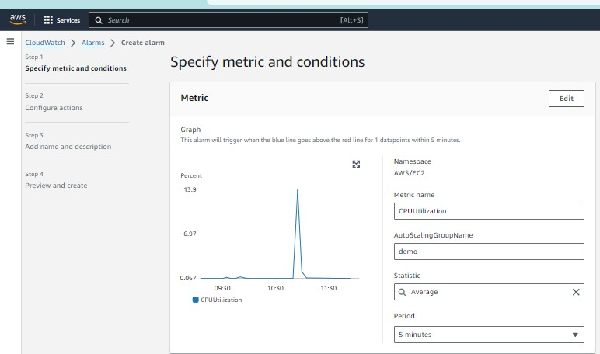

Select the conditions

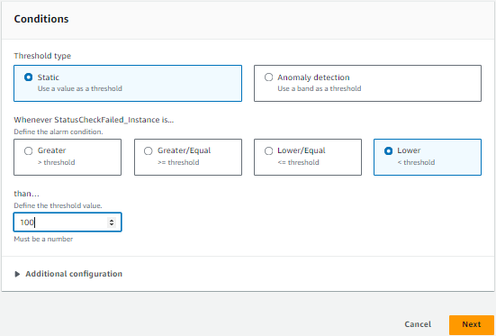

Here select our topic we created earlier

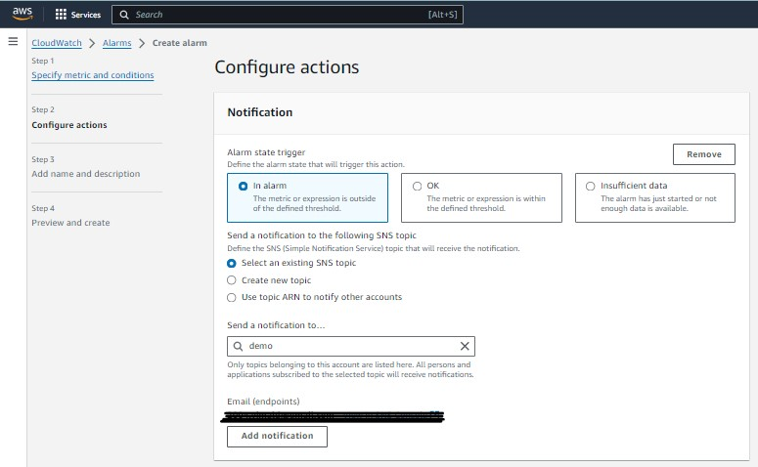

Now we can see our mail

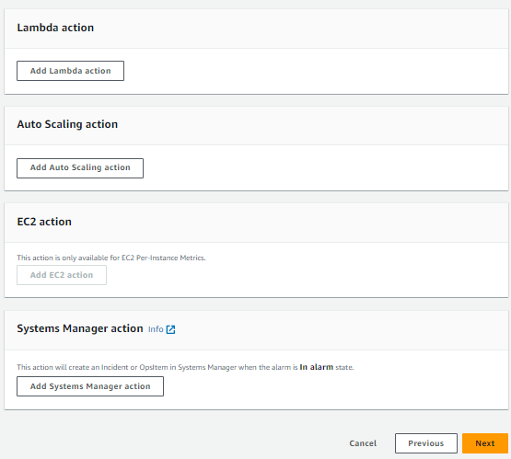

Give a alarm name

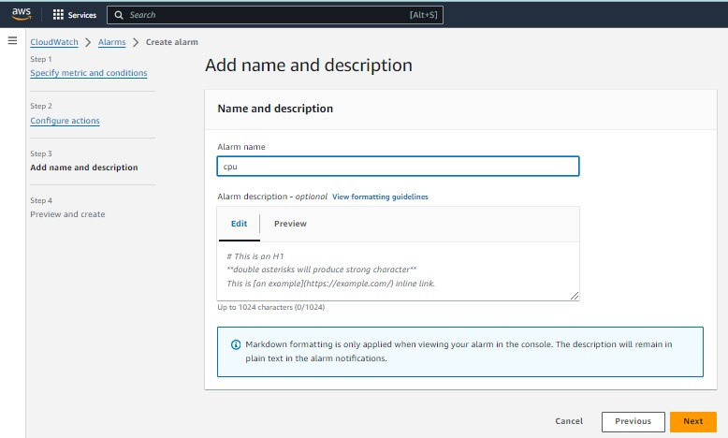

Give a review and create it 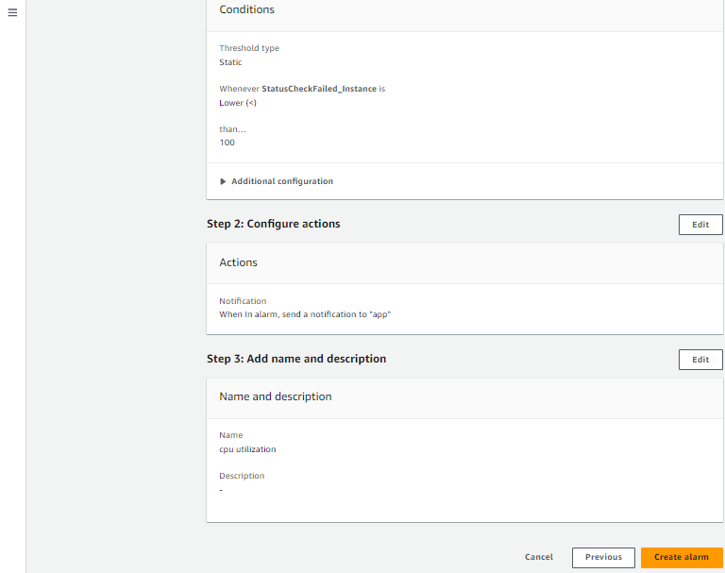

Here we can see our alarm

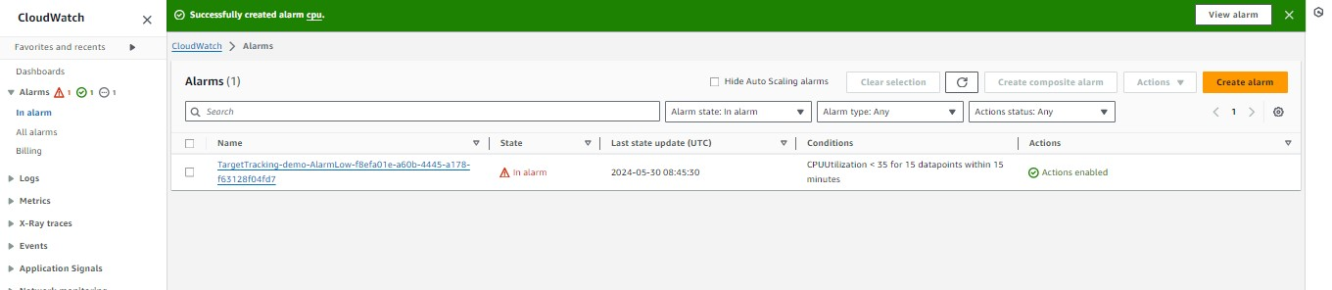

In our case if a instance is running with no usage it will be mailed like this 